

Write your name below:

Solutions

_______________________________________________

**Hale School**

**Year 11 Semester 1 Examination, 2017**

**Mathematics   
Methods**

**Circle your teacher**

**VMU MPC IFB MS SAV BAH**

**Section Two:  
Calculator-assumed  
  
Booklet 3 of 3**

­­­­­­­­­

42

TIME ALLOWED FOR THIS SECTION

Reading time before commencing: Ten minutes  
Working time for paper: One hundred minutes

**MATERIAL REQUIRED/RECOMMENDED FOR THIS PAPER**

*TO BE PROVIDED BY THE SUPERVISOR*

**TWO** Question/Answer booklets for Section Two – complete BOTH.

Formula Sheet (retained from Section One).

*TO BE PROVIDED BY THE CANDIDATE*

*Standard Items*: pens (blue/black preferred), pencils (including coloured), sharpener,   
 correction fluid/tape, eraser, ruler, highlighters

*Special Items*: drawing instruments, templates, notes on two unfolded sheets of A4 paper, and   
 calculators approved for use.

**IMPORTANT NOTE TO CANDIDATES**

No other items may be taken into the examination room. It is your responsibility to ensure that you do not have any unauthorised notes or other items of a non-personal nature in the examination room. Please check carefully, and if you have any unauthorised material with you, hand it to the supervisor **BEFORE** reading any further.

**STRUCTURE OF THIS PAPER**

|  |  |  |  |  |  |
| --- | --- | --- | --- | --- | --- |
| Section | Number of questions available | Number of questions to be answered | Working time (minutes) | Marks available | Percentage of exam |
| Section One:  Calculator-free | 10 | 10 | 50 | 53 | 35 |
| Section Two:  Calculator-assumed | 13 | 13 | 100 | 88 | 65 |
|  | | |  | **Total** | 100 |

**INSTRUCTIONS TO CANDIDATES**

1. Write your answers in this Question/Answer Booklet.
2. You must be careful to confine your responses to the specific questions asked and to follow any instructions that are specific to a particular question.
3. Spare pages are included at the end of this booklet. They can be used for planning your responses and/or as additional space if required to continue an answer.

● Planning: If you use the spare pages for planning, indicate this clearly at the top of the page.

● Continuing an answer: If you need to use the space to continue an answer, indicate   
 in the original answer space where the answer is continued, i.e. give the page number.

Fill in the number of the question that you are continuing to answer at the top of the page.

1. Show all your working clearly. Your working should be in sufficient detail to allow your answers to be checked readily and for marks to be awarded for reasoning. Incorrect answers given without supporting reasoning cannot be allocated any marks. For any question or part question worth more than two marks, valid working or justification is required to receive full marks. If you repeat any question, ensure that you cancel the answer you do not wish to have marked.
2. It is recommended that you do not use pencil, except in diagrams.

Section Two: Calculator Assumed   
This section has 13 questions. Answer all questions. Write your answers in the spaces provided.  
Working time: 100 minutes  
_______________________________________________________________________________

**8. [2, 2, 2 = 6 marks]**

State the period and amplitude of the following functions.

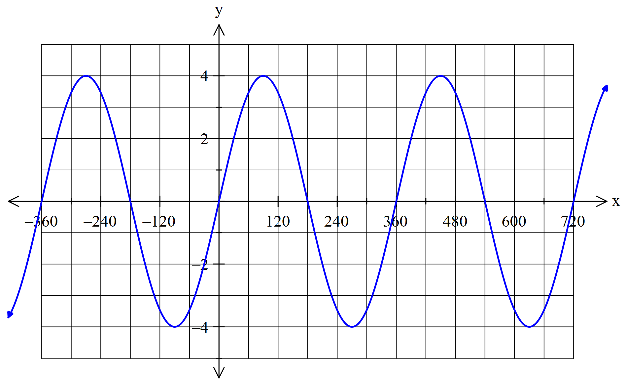

(Degrees)

|  |  |
| --- | --- |
| **Solution** | **Specific Behaviours** |
|  | * States correct period * States correct amplitude |

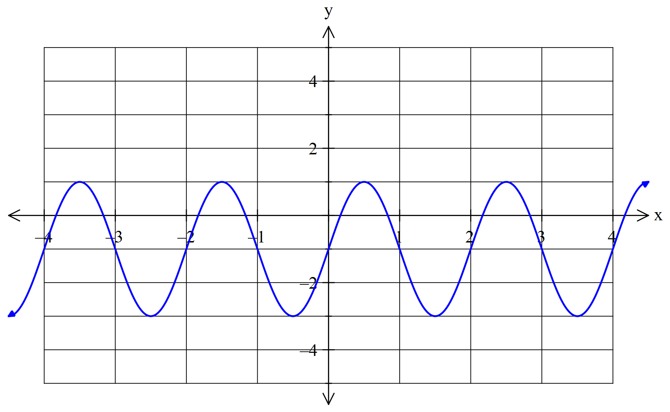

(Radians)

|  |  |
| --- | --- |
| **Solution** | **Specific Behaviours** |
|  | * States correct period * States correct amplitude |

1. 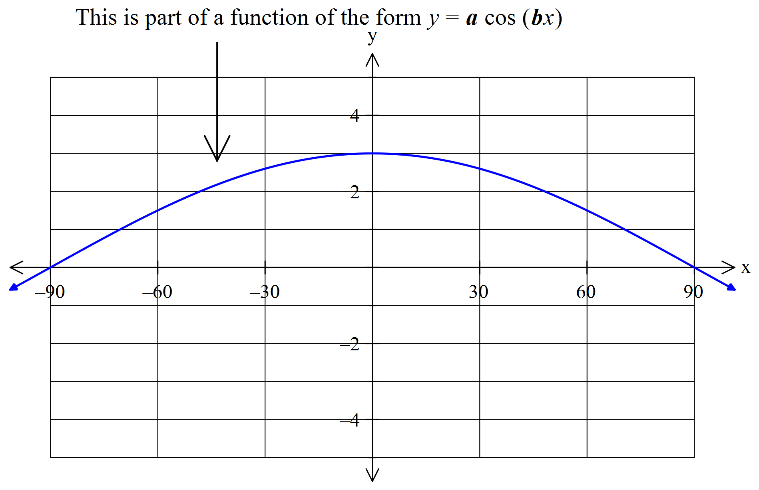

(Degrees)

|  |  |
| --- | --- |
| **Solution** | **Specific Behaviours** |
|  | * States correct period * States correct amplitude |

**9. [2, 3, 2 = 7 marks]**

Determine the equation of each of the following functions:

(a)

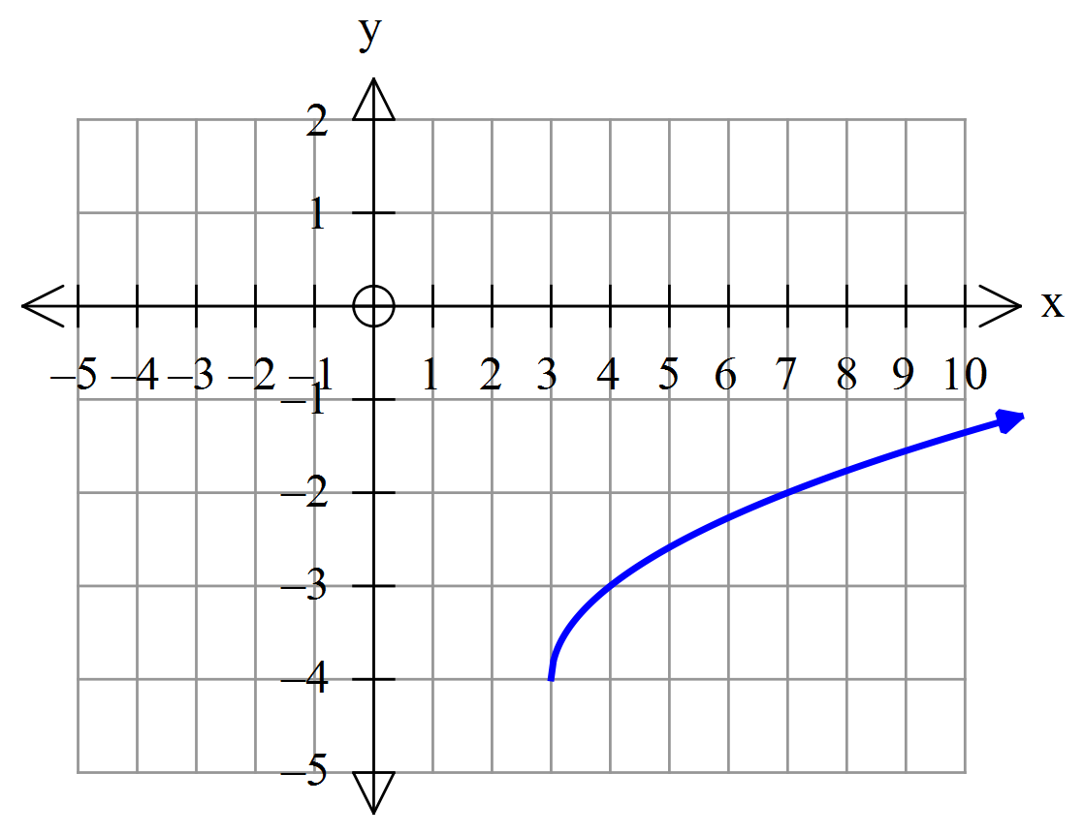

|  |  |
| --- | --- |
| **Solution** | **Specific Behaviours** |
|  | * Correct horizontal translation and function * Correct vertical Translation |

(b)

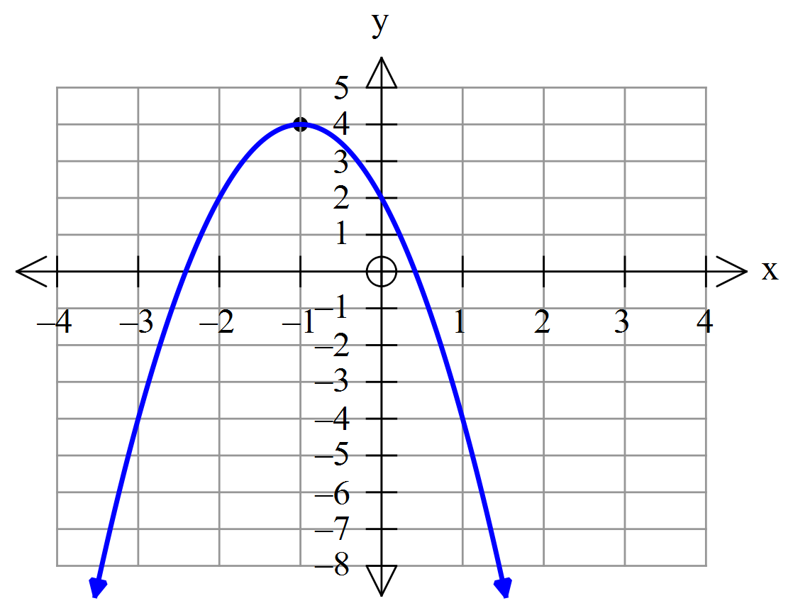

|  |  |
| --- | --- |
| **Solution** | **Specific Behaviours** |
|  | * Correct vertical dilation and reflection * Correct vertical and horizontal translation |

(c)

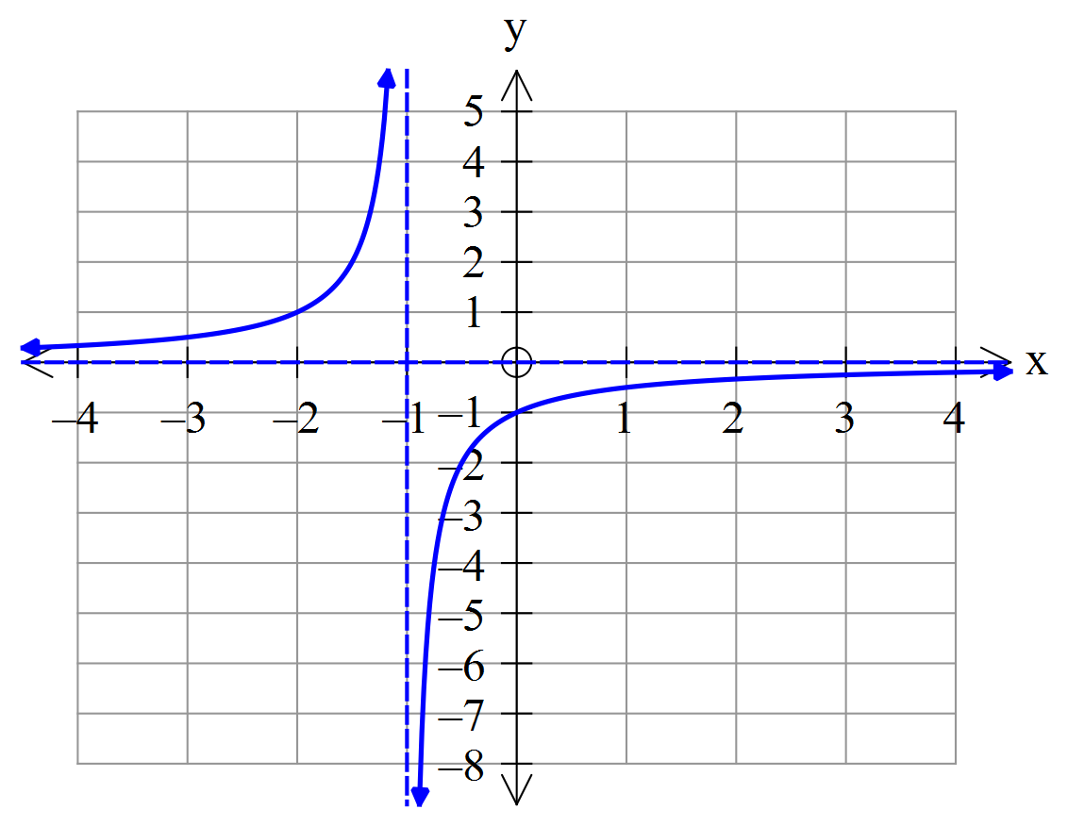

|  |  |
| --- | --- |
| **Solution** | **Specific Behaviours** |
|  | * Correct function * Correct horizontal translation |

**10. [1, 1, 2, 2 = 6 marks]**

While playing basketball Chris gets the opportunity to shoot for a goal from the penalty line. The path of the ball as it leaves her hand can be described by the function,



where $h$ is the height of the ball in metres and $x$ is the horizontal distance, also in metres.

1. How high is the ball when it leaves Chris’s hand?

|  |  |
| --- | --- |
| **Solution** | **Specific Behaviours** |
| Screen Clipping | * States correct height |

1. What is the maximum height the ball reaches?

|  |  |
| --- | --- |
| **Solution** | **Specific Behaviours** |
| Screen Clipping | * States correct height |

1. How far away from Chris will the ball hit the ground?

|  |  |
| --- | --- |
| **Solution** | **Specific Behaviours** |
| Screen Clipping | * States correct distance |

1. Given that the penalty line is 6 metres from the ring and the ring is 3 metres high, could Chris have scored a goal? Explain.

|  |  |
| --- | --- |
| **Solution** | **Specific Behaviours** |
| Screen Clipping | * Confirm that it is a possibility * Reason why it is a possibility |

**11. [2, 2, 3 = 7 marks]**

Mobile phone use increased exponentially in the 1990s. Based on data from the 1990s, the number of U.S. mobile phone accounts (in millions) can be approximated by



where $x$ is the number of years since the start of 1994.

Based on the above formula,

1. how many mobile phone accounts existed at the start of 1994?

|  |  |
| --- | --- |
| **Solution** | **Specific Behaviours** |
|  | * States correct value |

1. estimate the number of mobile phone accounts at the start of the year 2000.

|  |  |
| --- | --- |
| **Solution** | **Specific Behaviours** |
| Screen Clipping | * States correct value |

1. in which year was the number of mobile phone accounts double that compared to the start of 1994?

|  |  |
| --- | --- |
| **Solution** | **Specific Behaviours** |
|  | * Doubles value * States correct * States correct year |

**12. [3, 2, 3 = 8 marks]**

1. In the following diagram, find to the nearest metre:

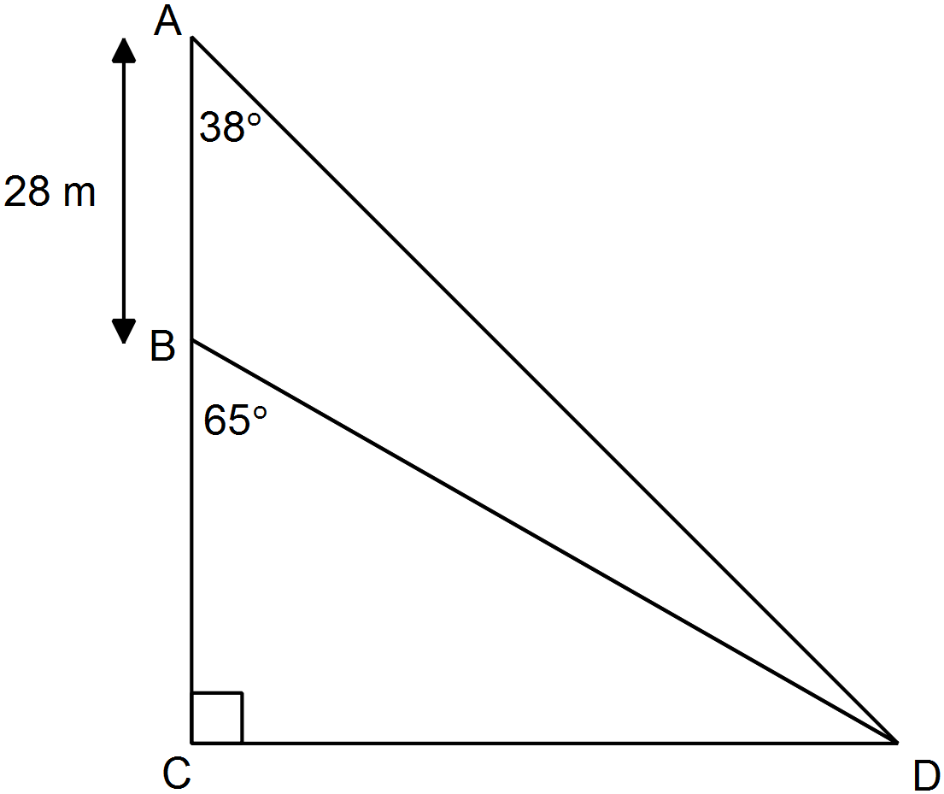

1. length BD

|  |  |
| --- | --- |
| **Solution** | **Specific Behaviours** |
|  | * Use sine rule to calculate side * Calculate correct  length * Correct rounding |

1. length CD

|  |  |
| --- | --- |
| **Solution** | **Specific Behaviours** |
|  | * Use sine rule to calculate side * Calculate correct  length |

(b) Which is greater, the area of  or the area of ?   
Justify your answer with appropriate working.

|  |  |
| --- | --- |
| **Solution** | **Specific Behaviours** |
|  | * Calculate correct are for * Calculate correct are for * States conclusion |

**13. [1, 2, 2, 1, 2 = 8 marks]**

The average wind speed, *S*(*t*) in km/h, over an 18 hour period from midnight to 6pm during a stormy day was observed to follow  where *t* was the number of hours since midnight.

(a) No data was available after 6pm as the measuring instrument broke at that time. What was the average wind speed at 6pm?

|  |  |
| --- | --- |
| **Solution** | **Specific Behaviours** |
|  | * States correct value |

(b) Sketch a graph to show how the average wind speed varied during the 18 hour period.

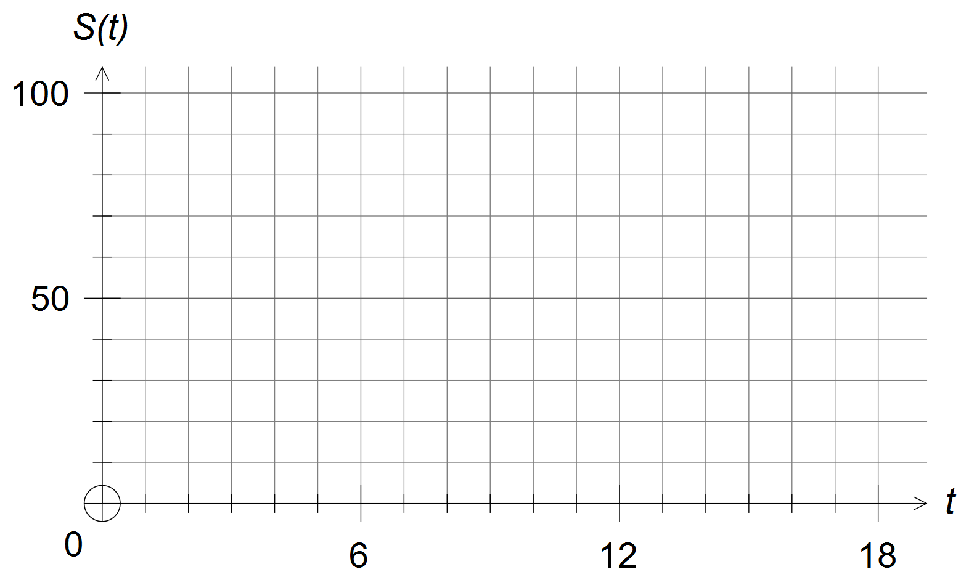

(c) At the height of the storm in the **morning**, some properties suffered structural and other damage. At what time, to the nearest quarter of an hour, did this occur?

|  |  |
| --- | --- |
| **Solution** | **Specific Behaviours** |
|  | * Finds * States correct time value |

(d) What was the lowest average wind speed recorded after 6am?

|  |  |
| --- | --- |
| **Solution** | **Specific Behaviours** |
|  | * States correct value |

(e) For what percentage of the 18 hours did the average wind speed exceed 50km/h?

|  |  |
| --- | --- |
| **Solution** | **Specific Behaviours** |
|  | * Calculates the correct time period * Calculate the correct % |

**END OF BOOKLET 3**

This page may be used for extra working space:

Question: ______

This page may be used for extra working space:

Question: ______

This page may be used for extra working space:

Question: ______